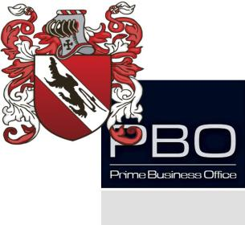

1|2
BASIC STOCKS INFORMATION SHEET

Company Name.

Stock Symbol & Exchange Where Trading.

Funding Amount Requested.

Funding Purpose.

Term Length Requested.
(Usual minimum term is 3 years with a 2 year lock out).

Name of Borrower on the Stock Shares.

Number of Pledging Shares.

Borrower Contact info.

2|2

Copy of Borrower’s Passport or Driver's License.

